**70+ companies call on the Commission to publish the MDMS Regulation by the end of the year**

To:

Maroš Šefčovič, Executive Vice-President for the European Green Deal

Adina Vălean, Commissioner for Transport

Wopke Hoekstra, Commissioner for Climate Action

Dear Commissioners,

As representatives of large companies, we are writing to you regarding the upcoming Regulation on Multimodal Digital Mobility Services (MDMS). We have learnt with disappointment that the legislative proposal of the Commission, initially planned for June 2023, has been again delayed.

In our sectors, we are committed to take our part in climate mitigation and as such are reducing our emissions overall including our business travel emissions.

**To help us achieve this goal, we need the European Commission to legislate on better ticketing and publish by the end of its year its proposal for a MDMS Regulation.** The reduction of emissions from corporate travel cannot be tackled without improving multi-modal and cross-border ticketing.

One of the barriers we face, to travel cross-border by rail, is the lack of ticket information shared by transport operators to booking platforms. We are increasingly looking for more sustainable travel options, but booking tools often can only show the flight option. To support the European Green Deal ambitions, the MDMS Regulation must enable easier booking of multimodal transport journeys involving different transport offers into a single booking. To achieve this, the EU should mandate transport operators to let all booking platforms sell their tickets under fair, reasonable and non-discriminatory conditions.

As representatives of large companies, we are calling on the EU Commission to publish the MDMS proposal to support the effort to reduce travel emissions, giving us the opportunity to easily book the most sustainable transport modes.





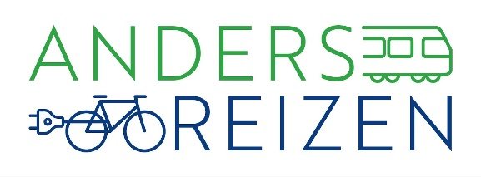

*Coalition Anders Reizen consists of* [*70 major employers*](https://www.andersreizen.nu/deelnemers/) *in the Netherlands with the ambition to halve their CO2 emissions from business travel by 2030 (compared to 2016).*